**Question Bank**

Q.1 What do u understand with computer graphics? What are the different types of computer graphics?

**the use of computers to create and manipulate meaningful information in the form of images**. These images come in many different forms, like [icons](https://www.flaticon.com/free-icons/aesthetic) and sketches. Any time you turn on the computer and see even just as much as your desktop background, you’re subjected to graphics.

Computer graphics can be separated into two different categories: **raster graphics** and **vector graphics**.

* **Raster Graphics:** In raster, graphics pixels are used for an image to be drawn. It is also known as a bitmap image in which a sequence of images is into smaller pixels. Basically, a bitmap indicates a large number of pixels together.
* **Vector Graphics:** In vector graphics, mathematical formulae are used to draw different types of shapes, lines, objects, and so on.

Q.2. Write the different uses, components, and applications of Computer Graphics?

**Computer Graphics refers to several things:**

* The manipulation and the representation of the image or the data in a graphical manner.
* Various technology is required for the creation and manipulation.
* Digital synthesis and its manipulation.

**Types of Computer Graphics**

* **Raster Graphics:** In raster, graphics pixels are used for an image to be drawn. It is also known as a bitmap image in which a sequence of images is into smaller pixels. Basically, a bitmap indicates a large number of pixels together.
* **Vector Graphics:** In vector graphics, mathematical formulae are used to draw different types of shapes, lines, objects, and so on.

**Applications**

* **Computer Graphics are used for**an **aided design for engineering and architectural system-** These are used in electrical automobiles, electro-mechanical, mechanical, electronic devices. For example gears and bolts.
* **Computer Art –** MS Paint.
* **Presentation Graphics –** It is used to summarize financial statistical scientific or economic data. For example- Bar chart, Line chart.
* **Entertainment-** It is used in motion pictures, music videos, television gaming.
* **Education and training-**It is used to understand the operations of complex systems. It is also used for specialized system such for framing for captains, pilots and so on.
* **Visualization-** To study trends and patterns.For example- Analyzing satellite photo of earth.

Q.3. Explain Frame Buffer and Video Controller?

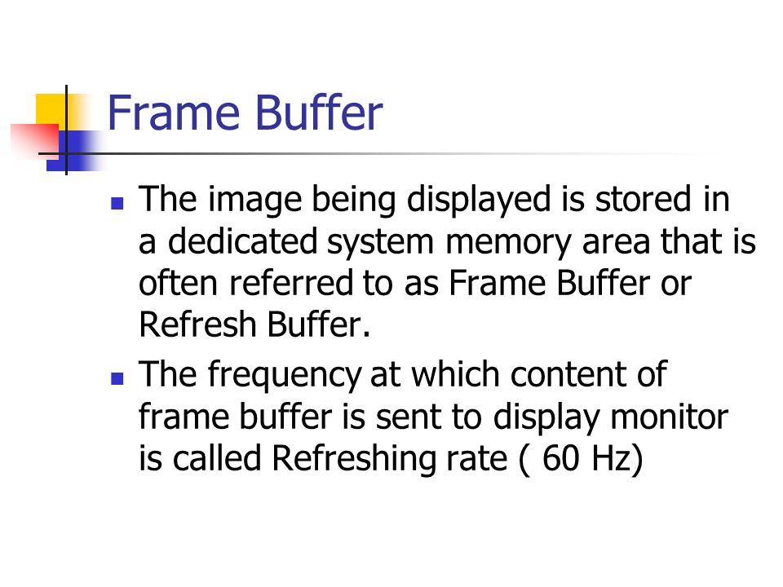

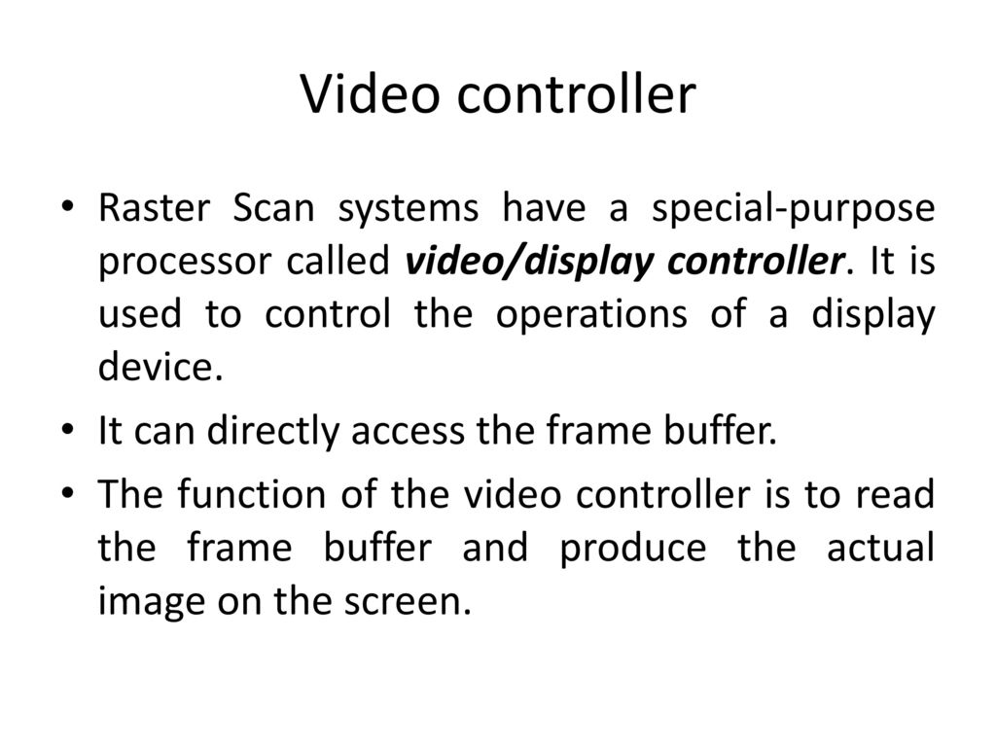

Q.4. Explain in detail Cathode Ray Tube (CRT), DVST (Different components and their functionalities, with Diagram).

# **Cathode Ray Tube (CRT):**

CRT stands for Cathode Ray Tube. CRT is a technology used in traditional computer monitors and televisions. The image on CRT display is created by firing electrons from the back of the tube of phosphorus located towards the front of the screen.

Once the electron heats the phosphorus, they light up, and they are projected on a screen. The color you view on the screen is produced by a blend of red, blue and green light.

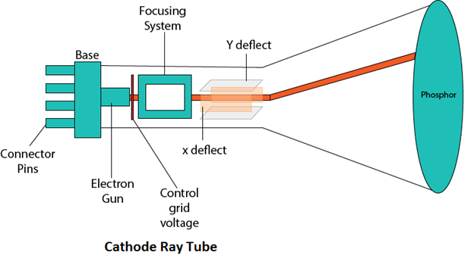

## Components of CRT:

Main Components of CRT are:

**1. Electron Gun:** Electron gun consisting of a series of elements, primarily a heating filament (heater) and a cathode. The electron gun creates a source of electrons which are focused into a narrow beam directed at the face of the CRT.

**2. Control Electrode:** It is used to turn the electron beam on and off.

**3. Focusing system:** It is used to create a clear picture by focusing the electrons into a narrow beam.

**4. Deflection Yoke:** It is used to control the direction of the electron beam. It creates an electric or magnetic field which will bend the electron beam as it passes through the area. In a conventional CRT, the yoke is linked to a sweep or scan generator. The deflection yoke which is connected to the sweep generator creates a fluctuating electric or magnetic potential.

**5. Phosphorus-coated screen:** The inside front surface of every CRT is coated with phosphors. Phosphors glow when a high-energy electron beam hits them. Phosphorescence is the term used to characterize the light given off by a phosphor after it has been exposed to an electron beam.

# **Direct View Storage Tubes:**

DVST terminals also use the random scan approach to generate the image on the CRT screen. The term "storage tube" refers to the ability of the screen to retain the image which has been projected against it, thus avoiding the need to rewrite the image constantly.

**Function of guns:** Two guns are used in DVST

1. **Primary guns:** It is used to store the picture pattern.
2. **Flood gun or Secondary gun:** It is used to maintain picture display.

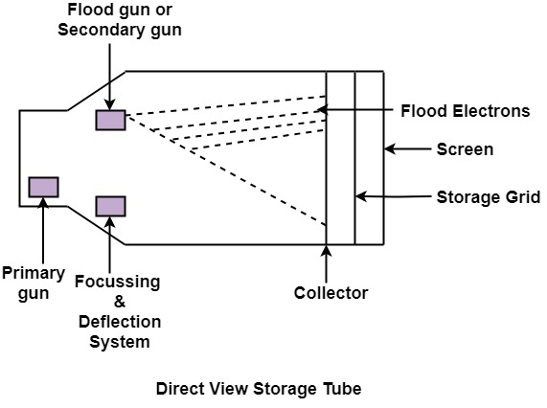

Q.5. Write about Raster Scan Display and Random Scan Display (Definition, working procedure, Functionalities, Advantages and Disadvantages and difference between them.)

# **Random Scan and Raster Scan Display:**

## Random Scan Display:

Random Scan System uses an electron beam which operates like a pencil to create a line image on the CRT screen. The picture is constructed out of a sequence of straight-line segments. Each line segment is drawn on the screen by directing the beam to move from one point on the screen to the next, where its x & y coordinates define each point. After drawing the picture. The system cycles back to the first line and design all the lines of the image 30 to 60 time each second. The process is shown in fig:

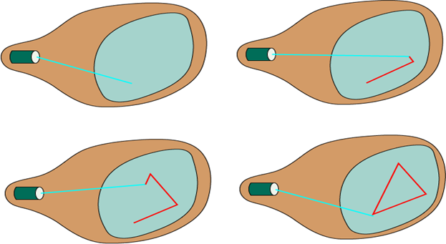

Random-scan monitors are also known as vector displays or stroke-writing displays or calligraphic displays.

## Advantages:

1. A CRT has the electron beam directed only to the parts of the screen where an image is to be drawn.
2. Produce smooth line drawings.
3. High Resolution

## Disadvantages:

1. Random-Scan monitors cannot display realistic shades scenes.

## Raster Scan Display:

A Raster Scan Display is based on intensity control of pixels in the form of a rectangular box called Raster on the screen. Information of on and off pixels is stored in refresh buffer or Frame buffer. Televisions in our house are based on Raster Scan Method. The raster scan system can store information of each pixel position, so it is suitable for realistic display of objects. Raster Scan provides a refresh rate of 60 to 80 frames per second.

Frame Buffer is also known as Raster or bit map. In Frame Buffer the positions are called picture elements or pixels. Beam refreshing is of two types. First is horizontal retracing and second is vertical retracing. When the beam starts from the top left corner and reaches the bottom right scale, it will again return to the top left side called at vertical retrace. Then it will again more horizontally from top to bottom call as horizontal retracing shown in fig:

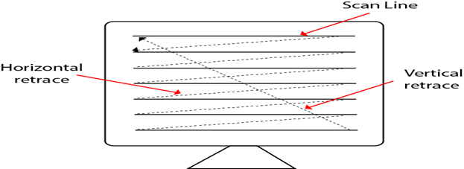

**Types of Scanning or travelling of beam in Raster Scan**

1. Interlaced Scanning
2. Non-Interlaced Scanning

In Interlaced scanning, each horizontal line of the screen is traced from top to bottom. Due to which fading of display of object may occur. This problem can be solved by Non-Interlaced scanning. In this first of all odd numbered lines are traced or visited by an electron beam, then in the next circle, even number of lines are located.

For non-interlaced display refresh rate of 30 frames per second used. But it gives flickers. For interlaced display refresh rate of 60 frames per second is used.

### **Advantages:**

1. Realistic image
2. Million Different colors to be generated
3. Shadow Scenes are possible.

### **Disadvantages:**

1. Low Resolution
2. Expensive

## Differentiate between Random and Raster Scan Display:

|  |  |
| --- | --- |
| **Random Scan** | **Raster Scan** |
| 1. It has high Resolution | 1. Its resolution is low. |
| 2. It is more expensive | 2. It is less expensive |
| 3. Any modification if needed is easy | 3.Modification is tough |
| 4. Solid pattern is tough to fill | 4.Solid pattern is easy to fill |
| 5. Refresh rate depends or resolution | 5. Refresh rate does not depend on the picture. |
| 6. Only screen with view on an area is displayed. | 6. Whole screen is scanned. |
| 7. Beam Penetration technology come under it. | 7. Shadow mark technology came under this. |
| 8. It does not use interlacing method. | 8. It uses interlacing |
| 9. It is restricted to line drawing applications | 9. It is suitable for realistic display. |

Q.6. Explain DDA Algo and discuss its pros and cons.

# **DDA Algorithm**

DDA stands for Digital Differential Analyzer. It is an incremental method of scan conversion of line. In this method calculation is performed at each step but by using results of previous steps.

### **Advantage:**

1. **It is a faster method than method of using direct use of line equation.**
2. **This method does not use multiplication theorem.**
3. **It allows us to detect the change in the value of x and y ,so plotting of same point twice is not possible.**
4. **This method gives overflow indication when a point is repositioned.**
5. **It is an easy method because each step involves just two additions.**

### **Disadvantage:**

1. **It involves floating point additions rounding off is done. Accumulations of round off error cause accumulation of error.**
2. **Rounding off operations and floating point operations consumes a lot of time.**
3. **It is more suitable for generating line using the software. But it is less suited for hardware implementation.**

## DDA Algorithm:

## 

Q.7. Explain Bresenham’s Algo and discuss its pros and cons.

# **Bresenham's Line Algorithm**

This algorithm is used for scan converting a line. It was developed by Bresenham. It is an efficient method because it involves only integer addition, subtractions, and multiplication operations. These operations can be performed very rapidly so lines can be generated quickly.

In this method, next pixel selected is that one who has the least distance from true line.

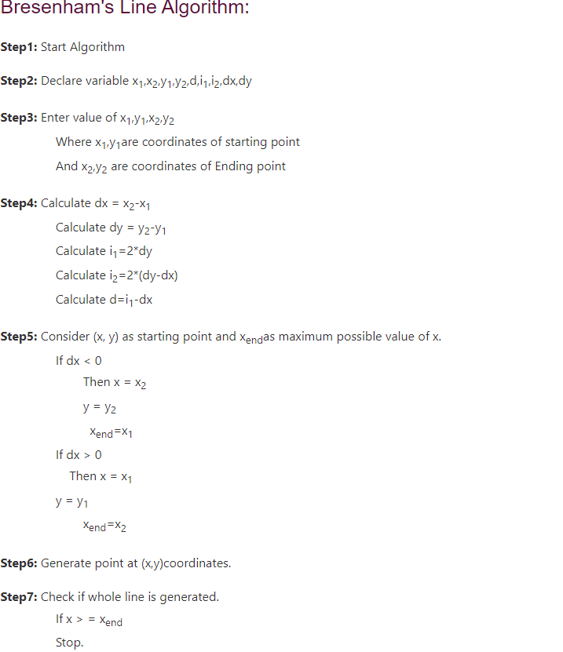

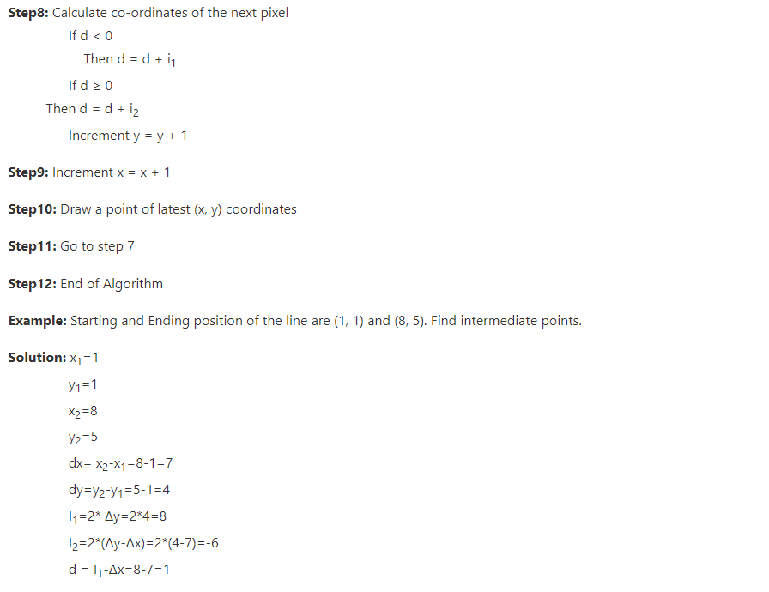

### **Advantage:**

1. It involves only integer arithmetic, so it is simple.

2. It avoids the generation of duplicate points.

3. It can be implemented using hardware because it does not use multiplication and division.

4. It is faster as compared to DDA (Digital Differential Analyzer) because it does not involve floating point calculations like DDA Algorithm.

### **Disadvantage:**

1. This algorithm is meant for basic line drawing only Initializing is not a part of Bresenham's line algorithm. So to draw smooth lines, you should want to look into a different algorithm.

Q.8. Explain Mid Point Circle Drawing Algo and discuss its pros and cons.

# **MidPoint Circle Algorithm**

It is based on the following function for testing the spatial relationship between the arbitrary point (x, y) and a circle of radius r centered at the origin:

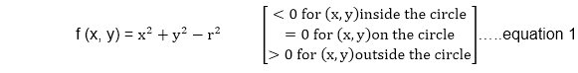  
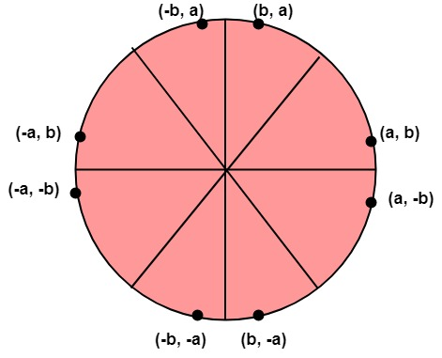

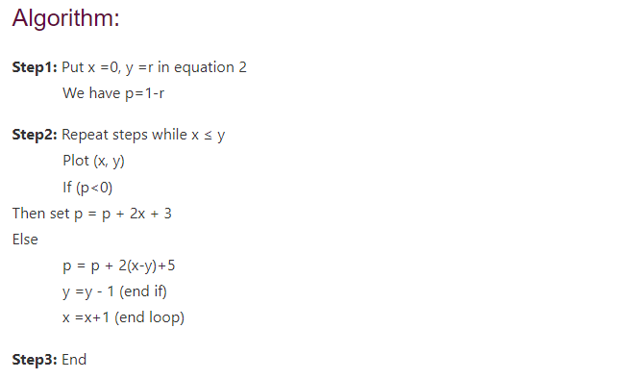

**Advantages:**

* The mid-point circle algorithm is an efficient algorithm in drawing a circle.
* The implementation of the algorithm is easy from the programmer’s point of view.

**Disadvantages:**

* The time consumption of this algorithm is high.

Q.9 Explain 2 D Geometric Transformation and its types.

**2D Geometric Transformation**

**Geometric Transformation:-** Geometric transformations are changes produced in orientation, size, and shape which alter the coordinates of the objects. Transformations are important throughout the creation of computer-generated images. In a graphic system, a programmer can define pictures that include a variety of transformations in many applications altering or manipulating of displays is required. The design application is created by arranging the orientation and sizes of the component parts of the scene.

The basic geometric transformation is translation rotation and scaling. Other transformations that are often applied to the objects are reflection and shear. Two transformations can be combined or concatenated to yield a single transformation with the same effect as the sequential application of the original two.

Thus transformation A might be a translation and transformation B might be a scaling. The concatenation property allows determining a transformation C=AB whose effect is to translate and t

hen to scale.

### **1. Translation:-**

The translation is a process of changing the position of an object in a straight line path from one co-ordinate location to another.

### **2. Scaling:-**

A scaling transformation is used to change the size of an object.

### **3. Rotation:-**

A two-dimensional rotation is applied to an object by repositioning it along a circular path in the plane.

### **4. Reflection:-**

A reflection is a transformation that produces a mirror image of an object relative to an axis of reflection.

### **5. Shear:-**

A transformation that slants the shape of an object is called the shear transformation.

Q.10. Write and derive the 2D Geometric Transformation equations.

The **translation** is the rigid body transformation that saves an object without deformation. A translation moves to a different position on the screen.

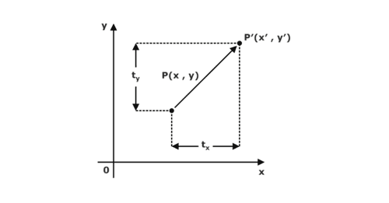

From the above figure, we can write that:

**X’ = X + tx**

**Y’ = Y + ty**

## 2D Rotation in Computer Graphics

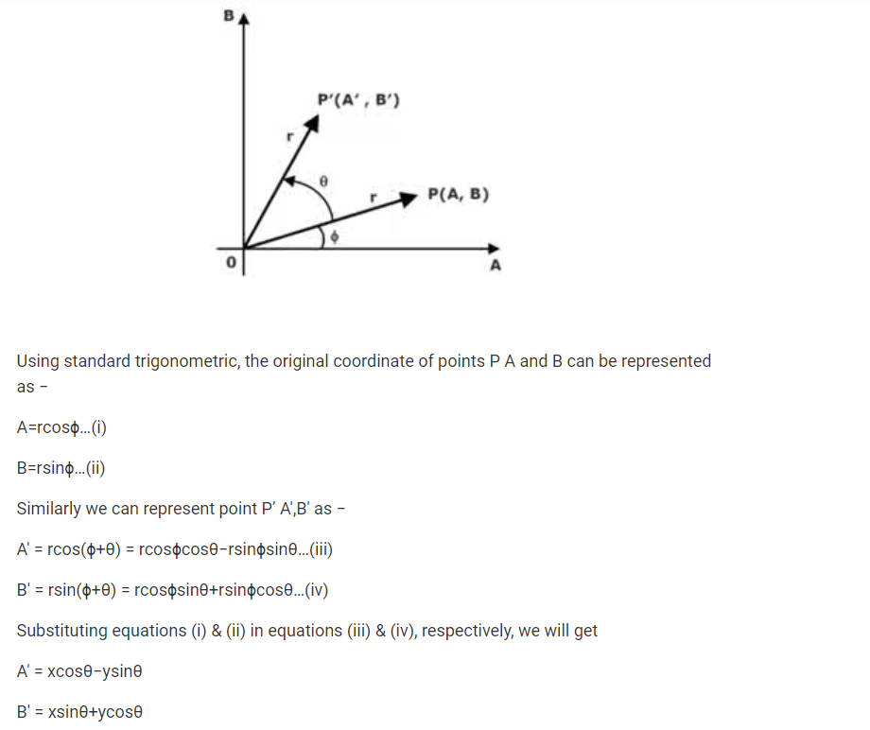

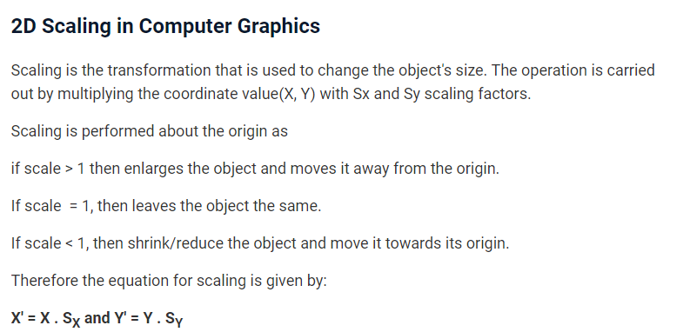

Q.11. Explain Homogeneous coordinates and why it is needed. Rewrite the transformation matrices using homogeneous coordinates.

Homogeneous coordinates is a mathematical concept used in computer graphics and computer vision to represent points and transformations in a projective space. In a 2D homogeneous coordinate system, a point is represented as a vector with three components: (x, y, w), where x and y are the coordinates of the point in 2D space, and w is a scaling factor. Similarly, in a 3D homogeneous coordinate system, a point is represented as a vector with four components: (x, y, z, w).

Homogeneous coordinates are needed in computer graphics and computer vision because they allow us to perform various transformations, such as translation, rotation, and scaling, using a single matrix multiplication operation. In traditional Cartesian coordinates, these transformations require different matrices, and they cannot be performed together in a single matrix multiplication operation.

To rewrite the transformation matrices using homogeneous coordinates, we need to augment the matrices with an extra row or column depending on the dimensionality of the space. For example, consider the transformation matrix for 2D translation:

| 1 0 dx |

| 0 1 dy |

| 0 0 1 |

To represent this transformation using homogeneous coordinates, we need to add an extra row to the matrix:

| 1 0 dx |

| 0 1 dy |

| 0 0 1 |

| 0 0 1 |

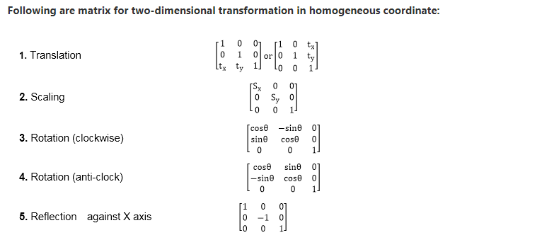

Q.12. Explain Composite Transformation.

# **Composite Transformation:**

A number of transformations or sequence of transformations can be combined into single one called as composition. The resulting matrix is called as composite matrix. The process of combining is called as concatenation.

Suppose we want to perform rotation about an arbitrary point, then we can perform it by the sequence of three transformations

1. Translation
2. Rotation
3. Reverse Translation

The ordering sequence of these numbers of transformations must not be changed. If a matrix is represented in column form, then the composite transformation is performed by multiplying matrix in order from right to left side. The output obtained from the previous matrix is multiplied with the new coming matrix.

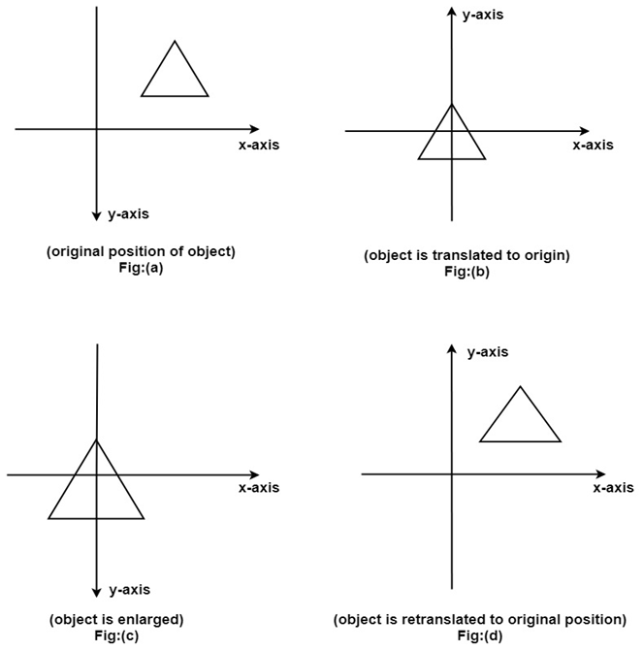

Advantage of composition or concatenation of matrix:

1. It transformations become compact.
2. The number of operations will be reduced.
3. Rules used for defining transformation in form of equations are complex as compared to matrix.

Numericals:-

Q.13. Calculate the Intermediate points of a line between the starting coordinates (5,4) and ending coordinates (12,7) using DDA Algo for Line Drawing.

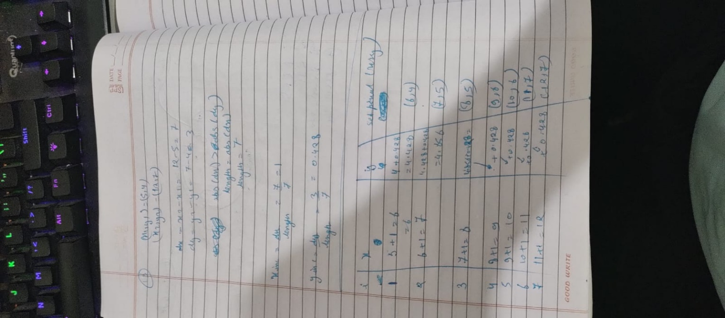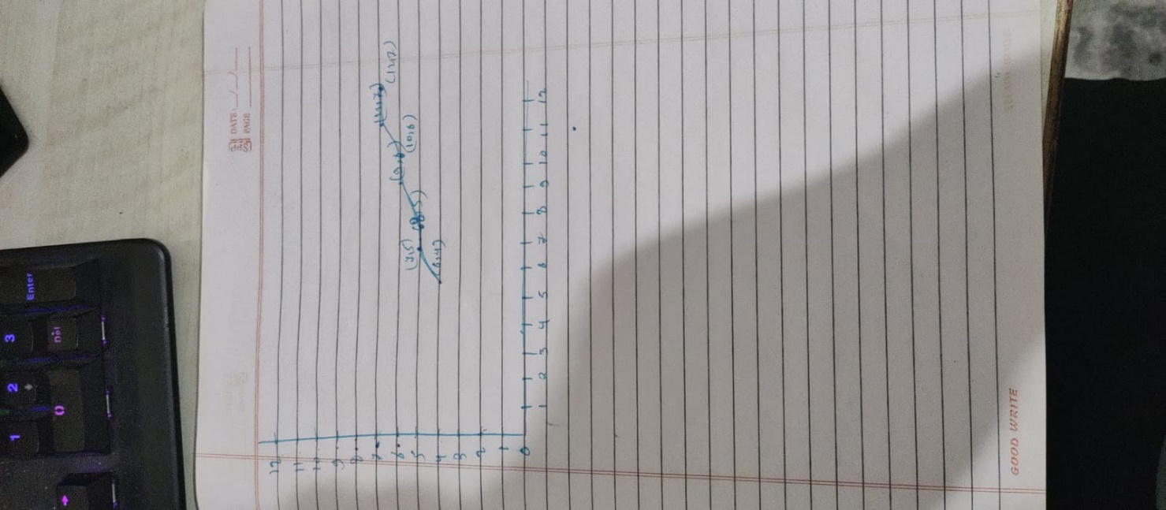

Q.14. Calculate the Intermediate points of a line between the starting coordinates (9, 18) and ending coordinates (14, 22) using DDA and Bresenham’s Algo for Line Drawing.

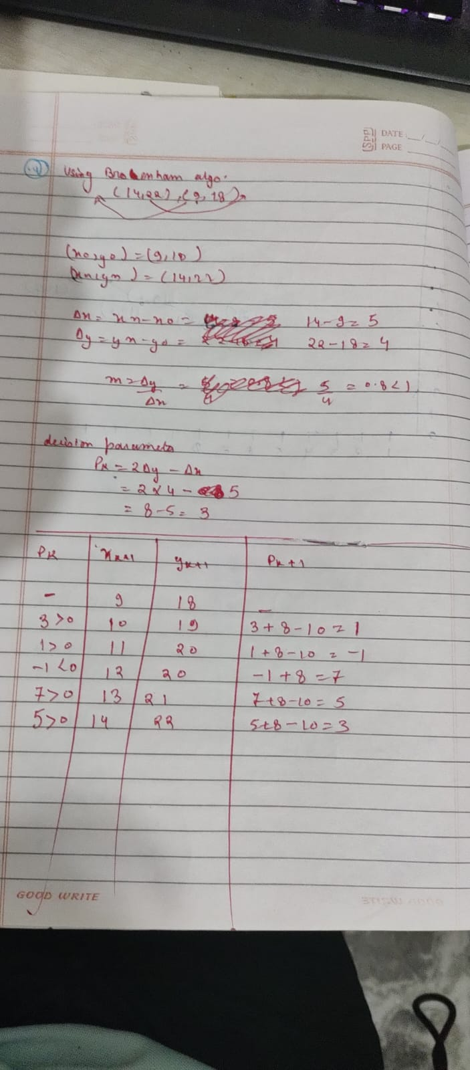

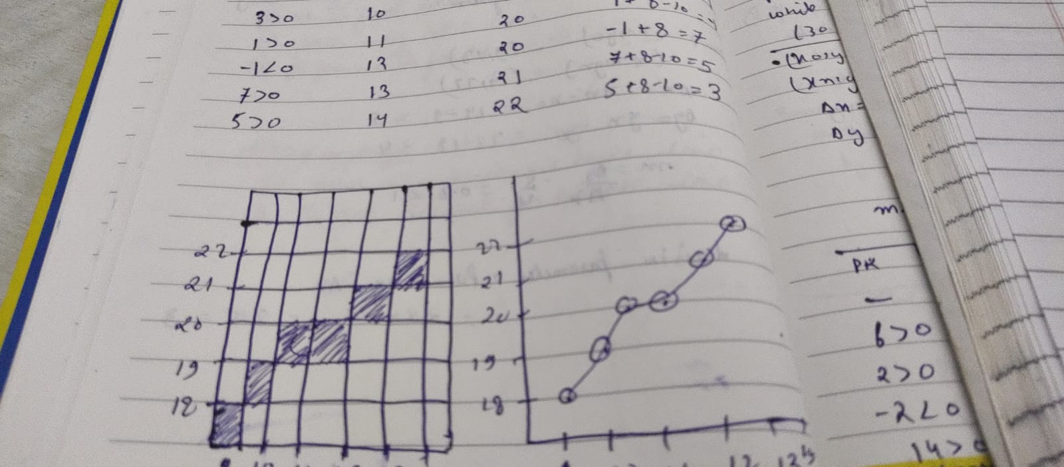

Q.15. Using the midpoint Circle drawing algorithm, Assuming 5 cm as the radius and origin (0,0) as the center of the circle, find the circle boundary points on a single quadrant to draw the given circle.

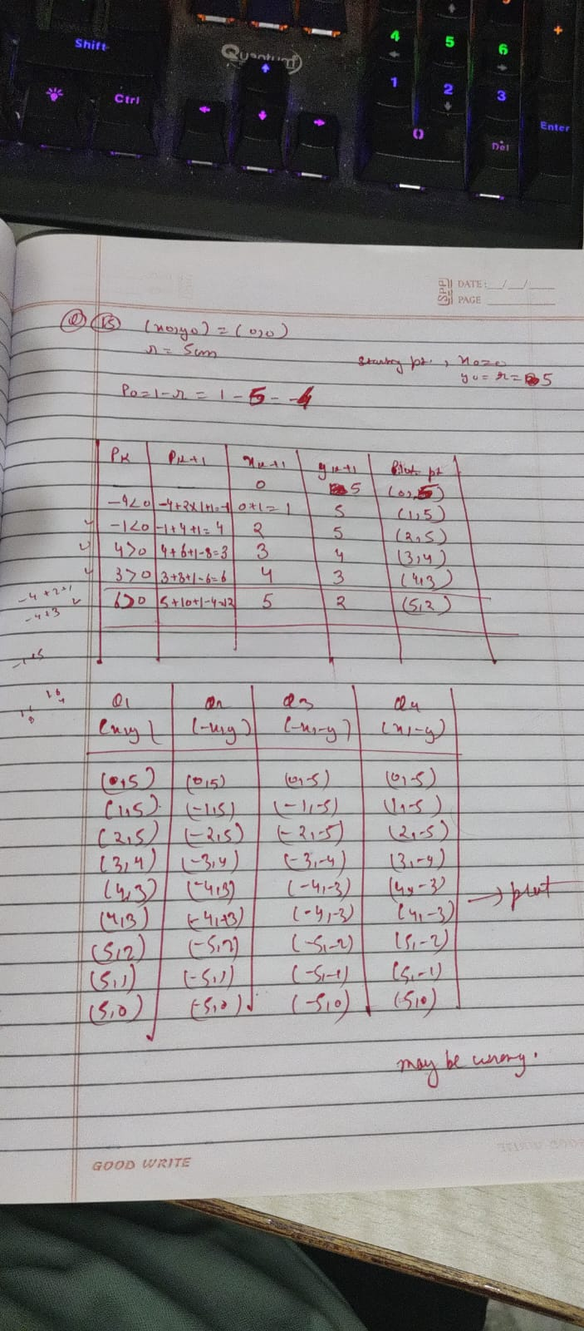

Q.16.  Given a circle C with radius 10 and center coordinates (1, 4). Apply the translation with distance 5 towards X axis and 1 towards Y axis. Obtain the new coordinates of C without changing its radius.

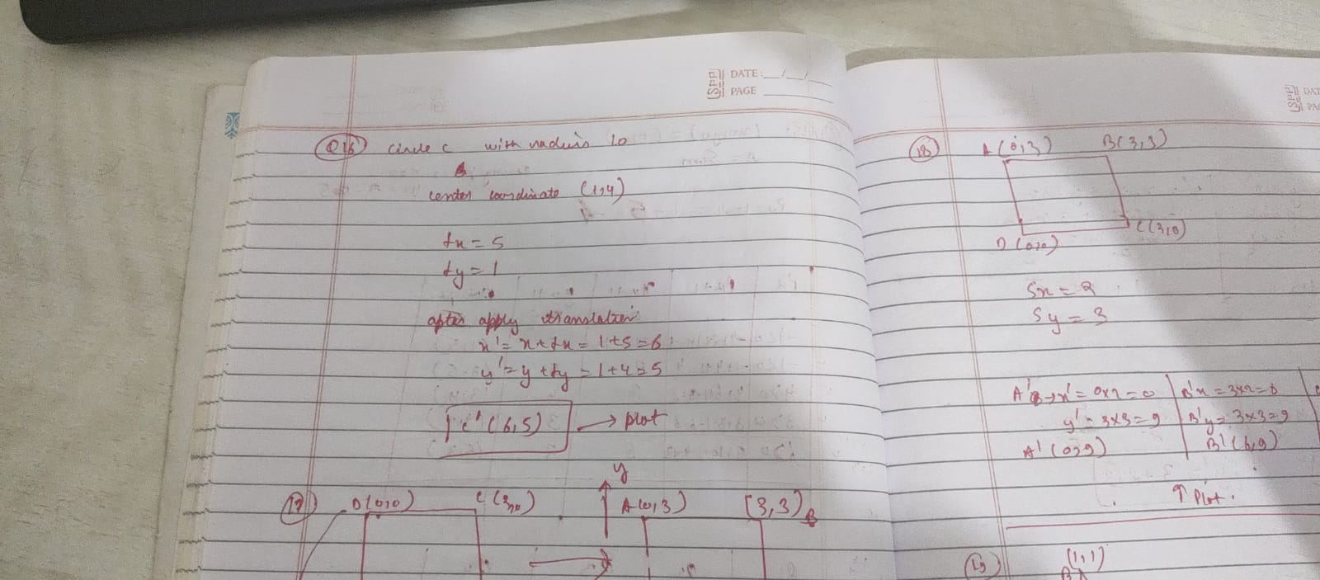

Q.17. Given a square with coordinate points A(0, 3), B(3, 3), C(3, 0), D(0, 0). Apply the translation with distance 1 towards X axis and 1 towards Y axis. Obtain the new coordinates of the square.

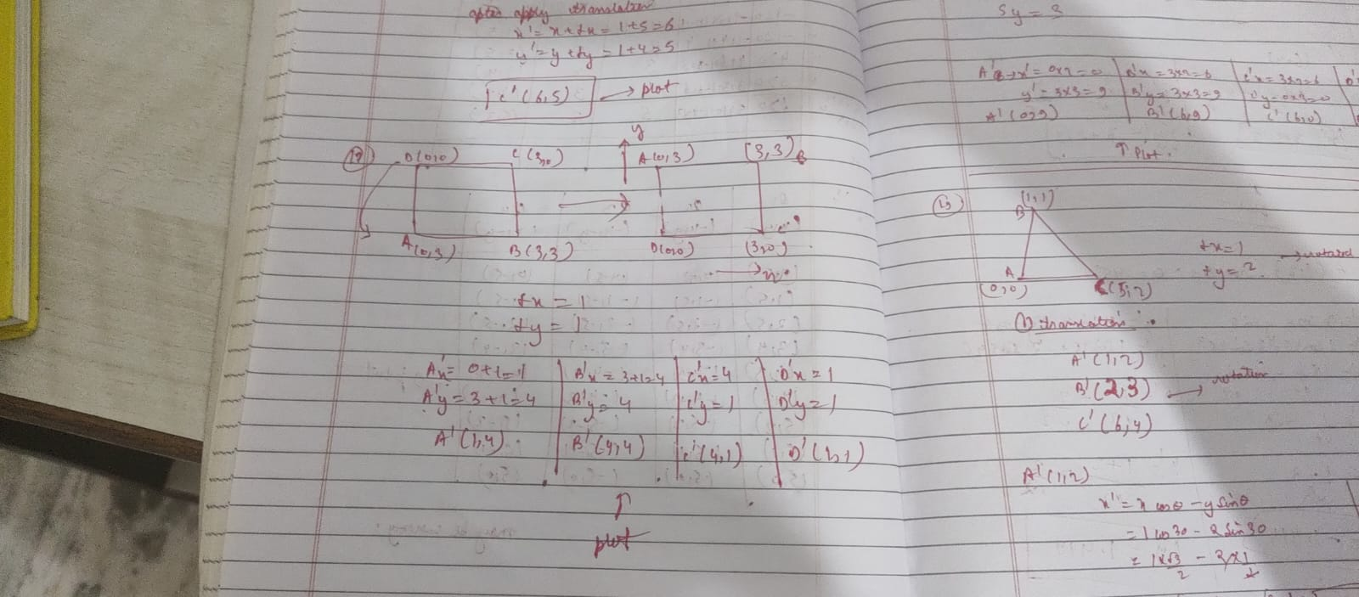

Q.18.  Given a square object with coordinate points A(0, 3), B(3, 3), C(3, 0), D(0, 0). Apply the scaling parameter 2 towards X axis and 3 towards Y axis and obtain the new coordinates of the object.

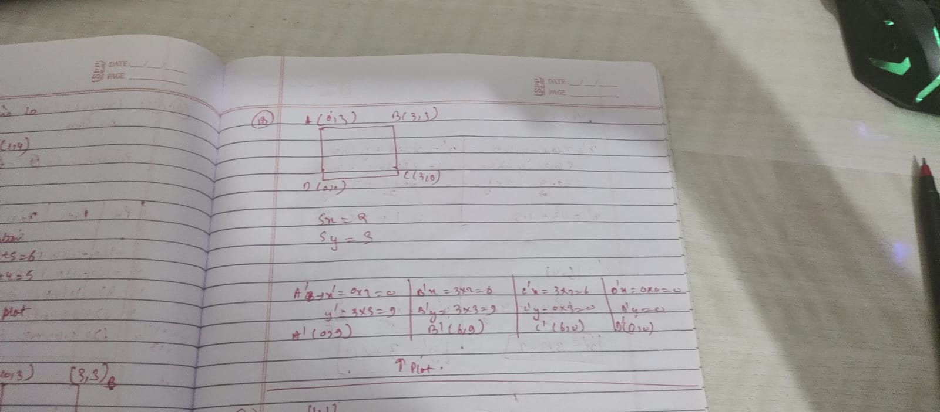

Q.19. A Triangle of given vertices (0,0), (1,1) and (5,2) is translated by factors of tx=1, ty=2 and then rotated anticlockwise with an angle of 30 degree. Find the resultant vertices of the triangle.

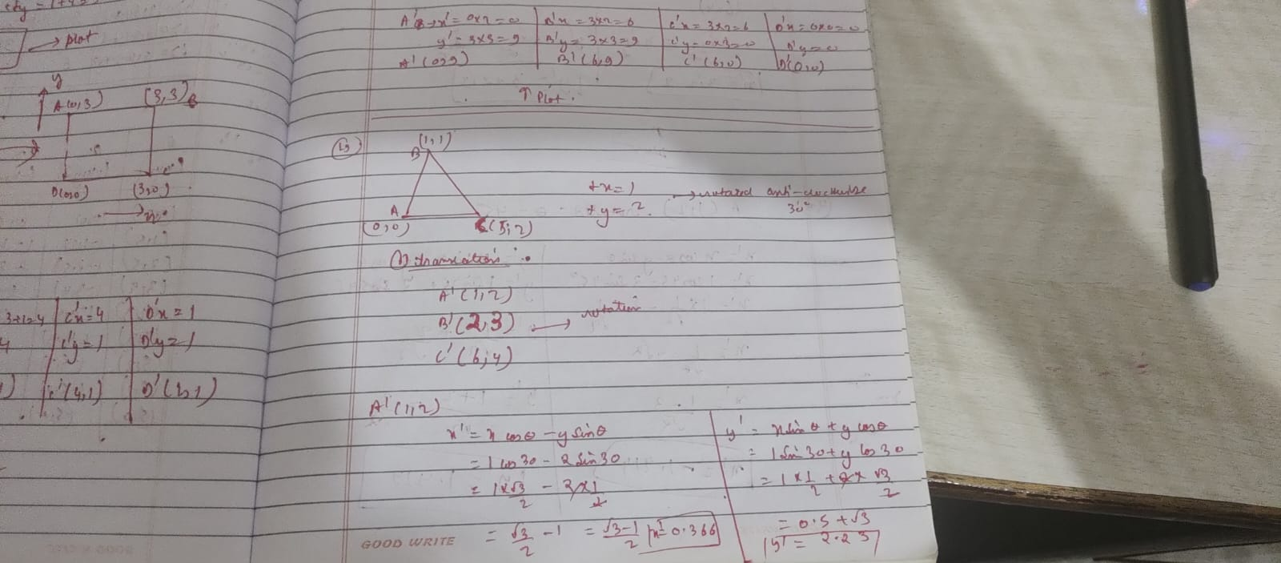

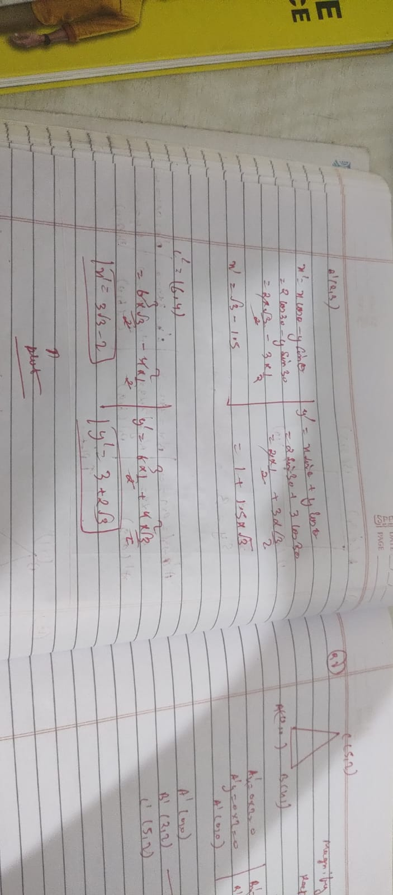

Q.20. A point (1,2) is rotated anticlockwise by an angle of 45 degree about the origin. compute the new point after rotation.

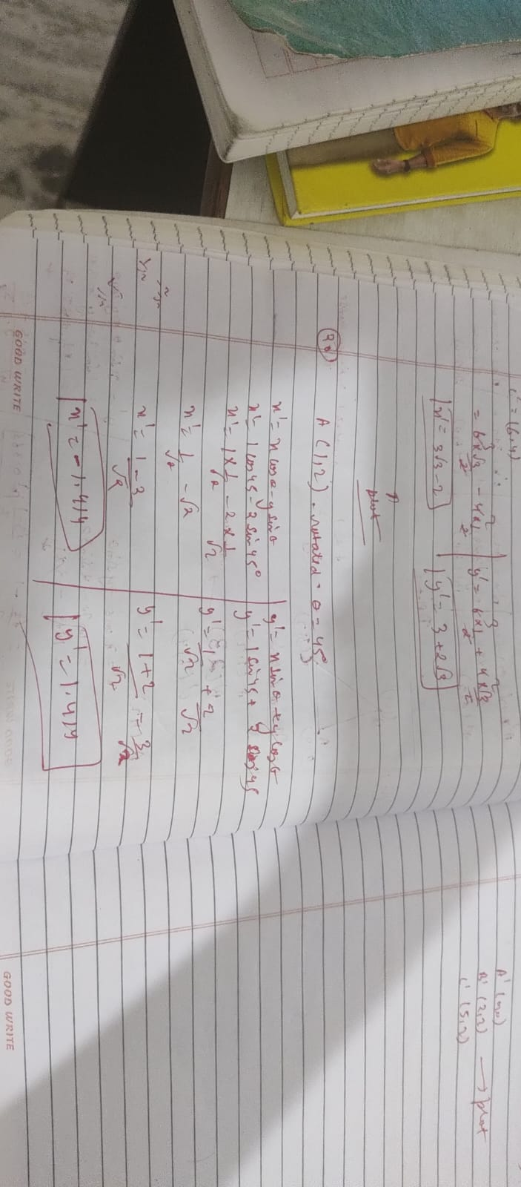

Q.21. Magnify the triangle with vertices A (0,0), B(1,1) and C(5,2) to twice its size while keeping c(5,2) fixed.

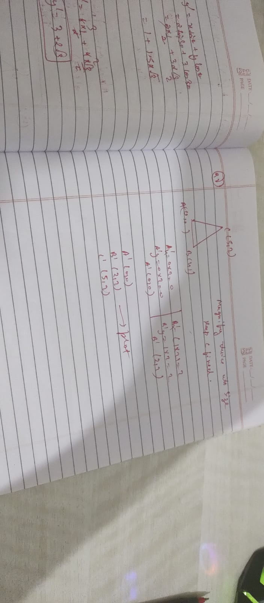

(Practice Similar questions on DDA, Bresenham’s, Midpoint Circle algo and Transformation.)